Signature Analytics Careers
_____________________________________________________________________________________
Sample image above
*we are putting the COOL back into ACCOUNTING one CLIENT at a time
(wording over an image)
_____________________________________________________________________________________
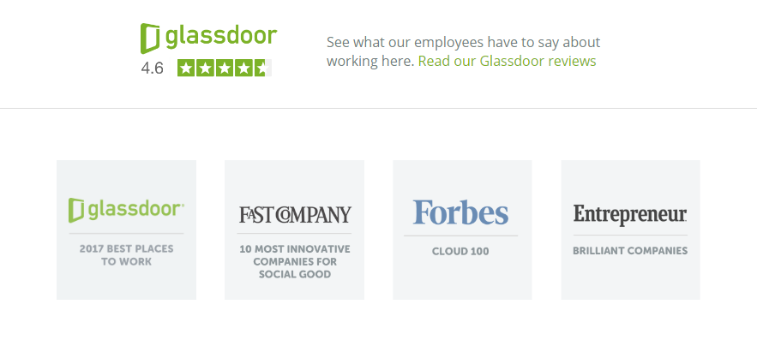
** SDBJ 3rd Fastest Growing company
** INC 500 List
** Ability to add other awards please
_____________________________________________________________________________________
IT’S A PERKS PARTY
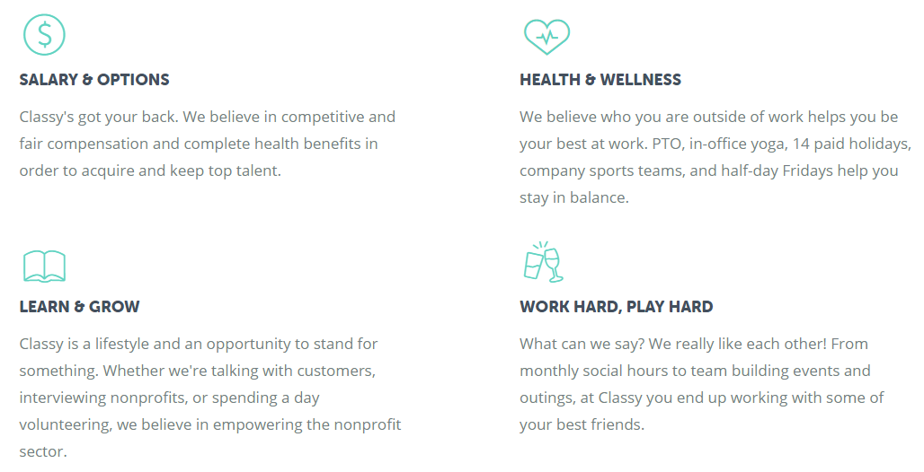

Sample image above See actual text below

WORK TO LIVE * NOT LIVE TO WORK
Unlimited PTO and flexible work schedules
Monthly team building activities such as day at the
races, baseball games, frequent happy hours
Volunteer days
No crazy hours or busy season!

MAKE IT RAIN
Competitive Salaries
Generous Quarterly bonus structure
Paid overtime
Mileage Reimbursement
CPA and CPA fee reimbursement
Excellent Benefits; Heath, Vision, Dental
401k Retirement Plan

THERE IS NO LIMIT TO YOUR POTENTIAL
Heavy focus on pushing work down to groom you for the next step in your career
Monthly career development trainings
Assigned mentor

NEVER A DULL MOMENT
Learn something new everyday
No two days are the same
Exposed to a variety of different industries

Employee and Client Referral Programs

_____________________________________________________________________________________

Phots and Core Values

**Add Core Values among images: Great People, Continuous Improvement, Client Success, Business Advisors
_______________________________________________________________________________________
Vision: To help business owners improve their performance and achieve their goals

_____________________________________________________________________________________
Current Open Positions (managed through Compass ---integrates with WordPress)
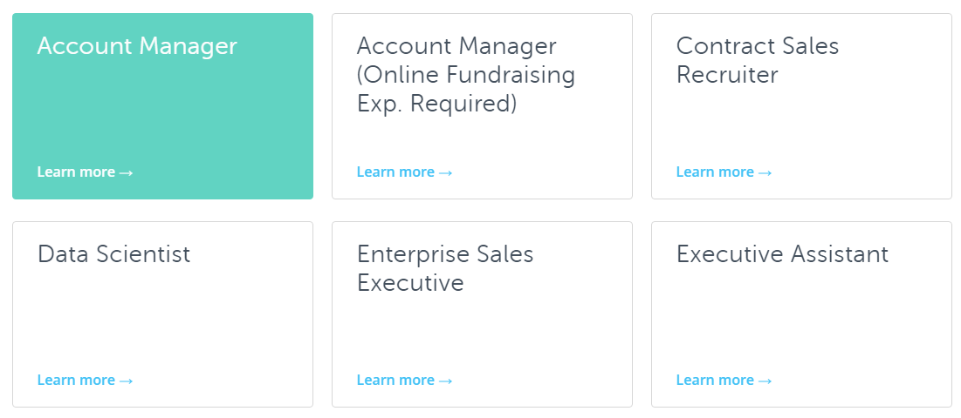

Images:

